Article Title (Put the title of your abstract here using both upper and lower case letters, Times New Roman, 12 pts, bold, centered, double spaced)
First Author¹, Second Author^{2,*}
¹ First Affiliation
² Second Affiliation
* Corresponding email:

Abstract: This general template helps you on preparing manuscript for “The 3rd International Conference on Vibration and Energy Harvesting Applications” (VEH 2021). Use this document as a template if you are using Microsoft Word 6.0 or later. Here comes self-contained abstract. VEH 2021 will focus on advances in the field of vibration and energy harvesting, and will provide an international platform for researchers from all over the world. Researchers can share their latest works on the development of the technologies related to vibration analysis, energy harvesting and their applications. All innovative research ideas and results on the mechanical design, optimization, dynamics, power management circuits and systems, MEMS technology, nano technology, new materials, self-powered IoT applications, and other related researches are welcome to the VEH 2021.
Keywords: Keyword 1; Keyword 2; Keyword 3 (3-5 keywords are required)

1. Introduction
This is the introduction of the manuscript.
2. General remarks on manuscript preparation
Generally, 1.5 line spacing, 12 pts font, and Times New Roman are preferred when you type the manuscript for review. Typing your manuscript follows the order: Title, Authors, Affiliations, Abstract, Keywords, Main text, Acknowledgements (optional), References (optional), Figure captions, Figures and Tables. Do use bold face, italic, subscripts, superscripts, etc., as appropriate.
2.1 Illustrations
The preferable figure formats are: EPS (for vector graphics) and TIF (for bitmaps). All artwork has to be numbered according to its sequence in the text. All of them should have captions. Generally, no vertical rules (lines) should be used in tables.
2.2 Equations
Conventionally, in mathematical equations variables and anything that represents a value appear in italics. You are encouraged to use equation-editing tools such as Mathtype to edit equations. Please make use of the numbering and referencing functions.
Acknowledgements
This section is optional.
References
If the reference is a journal paper:
[1]. Erturk A, Hoffmann J, Inman DJ. A piezomagnetoelastic structure for broadband vibration energy harvesting. Applied Physics Letters 2009; 94(25): 254102.
If the reference is a conference paper:
[2]. Nanda A, Karami M, Singla P. Uncertainty Quantification of Energy Harvesting Systems Using Method of Quadratures and Maximum Entropy Principle, In ASME 2015 Conference on Smart Materials, Adaptive Structures and Intelligent Systems, Colorado Springs, USA, September 21–23, 2015, SMASIS2015-9026.
If the reference is a book:
[3]. Nayfeh AH, Mook DT. Nonlinear oscillations. Wiley, Chichester; 2008.

(NOTIFICATION: Please submit an abstract with no more than 3 pages (References/ Acknowledgements are not required in abstract) through the Submission System: http://veh2020.scievent.com/submission/guidelines. The deadline of abstract submission is due by May 10, 2021. The notification of abstract acceptance will be sent out on May 15, 2021. You are highly encouraged to use this template for Abstract Submission, and please submit the abstract in the MS word version or the PDF version. This conference will not publish any proceedings. There is no copyright issue for the further publication elsewhere. The paper that is going to strive for BEST PAPER should submit a full-paper submission (3-6 pages are preferred, before June 20, 2021), please use this template as well. Best papers will be recommended to the Special Issue of the Journal of Intelligent Material Systems and Structures (JIMSS) and Mechanical Systems and Signal Processing (MSSP). Other related information will be updated online later.)
Figure Captions
Fig.1 The figure captions should be as brief as possible. It should also contain sufficient information that readers do not need to refer to the main text.

Fig.2 Put here the figure caption of figure 2 (also the legend to figure 2).

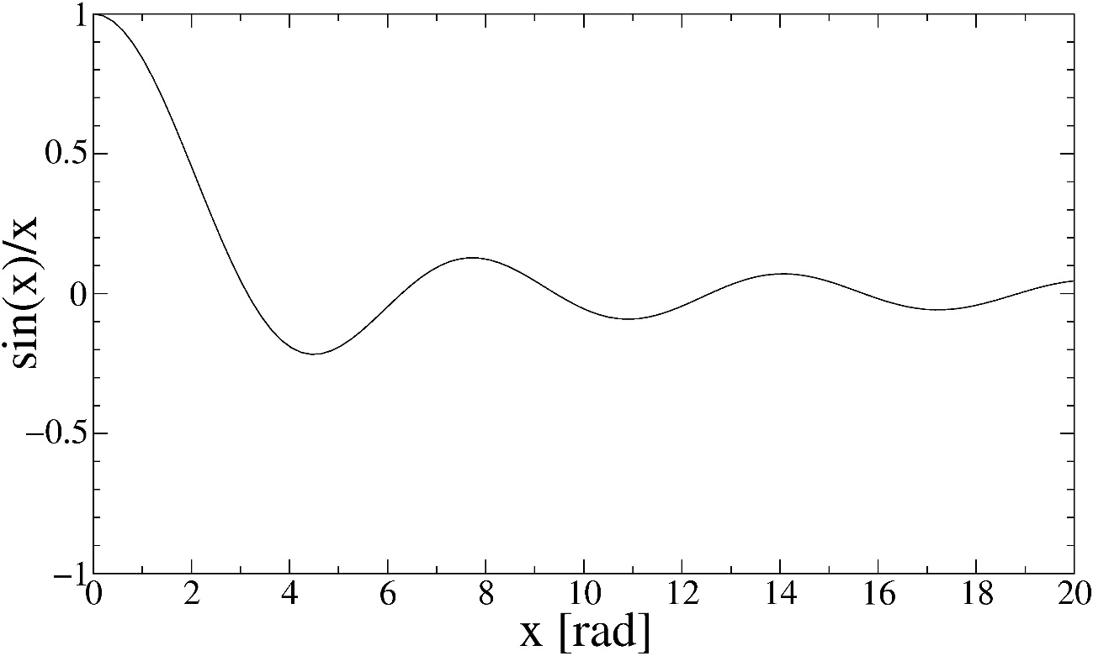
Fig. 1. Sample figure.
Table 1 Sample Table
Parameter | Compound 1 | Compound 2
a (Å) | 4.5832 | 4.9365
Δ Eª (eV) | 1.745 | 1.592
… | … | …
… | … | …
ª This is an example of a table footnote.

